DCSI User Guide to Veribook

- Register with Veribook to create an account using your Dartmouth email. Your display name should follow the format "Class Year_Last Name_First Name.”
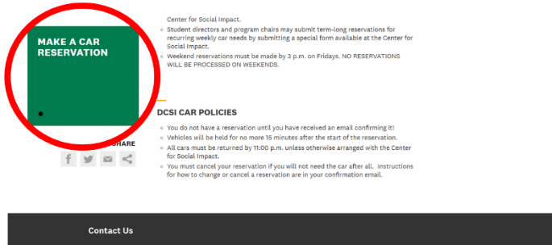
- Navigate to the Using DCSI Cars page on DCSI’s website. Scroll to the bottom left of the page and click on the green box “make a car reservation.”

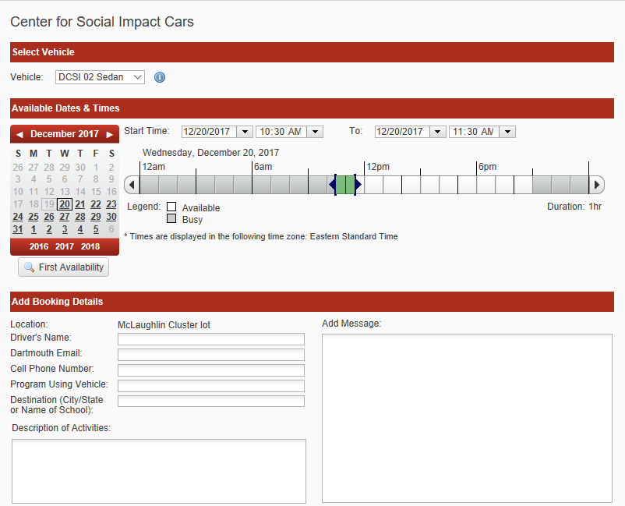
- Once on Veribook, use the calendar on the left-hand side of the window to select the date. Use the slider at the center of the screen to select the time of the reservation on the given day. Times which are grayed out are not available. Use the drop-down menu in the upper left-hand corner to look at the availability of the different vehicles. Mouse over the information icon to the right of the drop-down box to see information about the vehicle you are requesting.

- If there is no vehicle available for you, please contact: social.impact.cars@dartmouth.edu with the date, time and program of the request and we will do our best to accommodate.

- Once the date and time of the reservation is set, enter your full name under “Your Name”, your Dartmouth email address under “Contact Information”, and the name of the program for which you are using a car, as well as any other relevant information, under “Add message”.

- When you are sure that all information is correct, click "Send Request." If you have not already logged into Veribook, you will be prompted to do so. You should receive an email confirmation of your request within a few minutes.

- Your request for vehicle use will be processed within 24 hours. For reservation requests for the weekend and Monday, please submit your request by 4:30 PM on Friday. Please note that reservation requests are not processed after 4:30 PM on Friday.

- In response, you could then receive one of three different emails from the Veribook website.

- If your request has been processed and no changes have been made, you should receive a confirmation email. If this is the case (as it generally should be), no further interaction is required on the Veribook website for this reservation.

- If your request has been processed but a change was made by a DCSI staff (generally a change in the vehicle that is being reserved), you will receive an email with the subject “Booking Request Countered.” Click on the link within the email to return to Veribook and determine if the change is acceptable. If it is, click “Accept”. You should then receive a confirmation email. If the change is not acceptable (i.e. you need a minivan and you have been given a sedan), make a change to the reservation, write a brief message as to why you are requesting a change in the “Message” section, and click “Counter”.

- If your request has been processed and denied, you will receive an email with the subject "Booking Request Declined." You should also receive a separate email from DCSI explaining why your request was declined. The most common reasons for being declined are that you are not yet a certified driver, the cars have been grounded for the day, or that the reservation date in question was more than a week in advance.

- Once your request is confirmed, you should pick up the keys to your assigned vehicle:
- At DCSI between 8:30 AM - 5:00 PM, Monday through Friday OR
- At Safety and Security, located on the second floor of Dick's house, before 8:30 AM or after 5:00 PM on weekdays, OR
- At Safety and Security on the weekends.

- You will drop off the keys at the same location where they were picked up.
  - If you drop off keys at DCSI after 5:00 PM, the drop-box for keys is inside the foyer/atrium in locked white drop box.

- Questions? Email social.impact.cars@dartmouth.edu.

