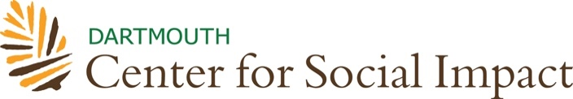
6154 South Fairbanks Hall
Hanover, New Hampshire 03755-3529
T (603) 646-3350
E service.internships@dartmouth.edu

Internships
CSO SUPERVISOR’S STATEMENT OF AGREEMENT

The student indicated below is applying for funding from the Dartmouth Center for Social Impact (DCSI) to support a remote social impact internship at your organization. Funding for this program is extremely competitive. Funding decisions are made within a month of the application due date. Submission of this form signifies to DCSI that your agency has agreed to provide the specific volunteer work assignment described below and has designated a specific supervisor to oversee that work. This Statement of Agreement records the details of funding. All selected DCSI Interns are covered by medical insurance. This agreement is not a legal contract, and is not forwarded to any public agencies. A student’s application for DCSI funding will not be considered complete until this form has been completed.

(Organization Name) agrees to take (Intern Name) into the organization as a remote intern and to provide at least 30-40 hours of meaningful service work during at least 8 weeks of the term, and to supervise this work to the degree that at the end of the internship a brief evaluation can be offered by the supervisor.

The offer of this internship is contingent upon award of a DCSI Internship (optional).

List of tasks and deliverables of internship:

Dartmouth Center for Social Impact provides interns with a stipend of up to $1,500, based on need, to help defray living costs.

Date:
Supervisor's Name:
Supervisor’s Title:
Supervisor's Signature:
(*electronic signature accepted)

Address:
Phone:
Is this a non-profit organization? Yes No
Does this organization serve an under-resourced community? Yes No
Is this organization non-partisan? Yes No

Does this internship require any pre-screens (ex. background check)?

If so, what are they?

Length of project: weeks Hours weekly:
Starting Date: Ending Date:
Return by deadline date of July 29th to:

Internships
Dartmouth Center for Social Impact, Dartmouth College
6154 South Fairbanks Hall
Hanover, NH 03755-3568
Phone: 603-646-3350 / Fax: 603-646-2645
Email: service.internships@dartmouth.edu

After return of this signed and completed Statement of Agreement from the Community Service Organization, the DPCS Intern, by his/her signature below, signifies that the terms of this Agreement are understood and accepted:

_______________________________________________________________________
(DCSI Internship applicant name) (Date)

