FREE

Register Online at https://students.dartmouth.edu/academic-skills/
Earn 1 PE Credit
Questions? Blitz: Academic.Skills.Center@Dartmouth.edu
Learning @ Dartmouth

Fall 2018

Just for the Class of 2022

Tuesdays and Thursdays 4:30-5:30 pm, Carson L02

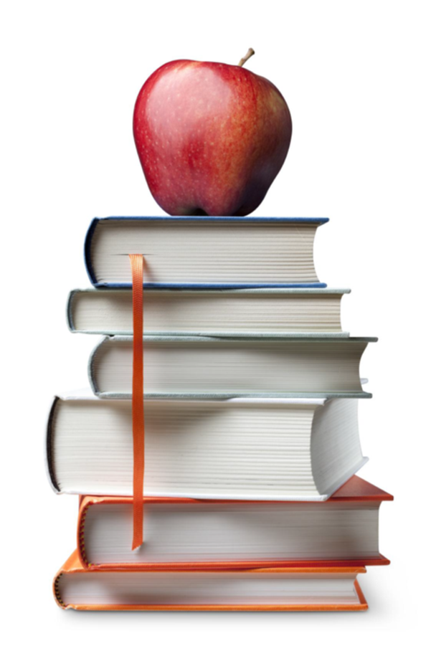
Session | Date | Topic
1 | Tues., Sept 18 | Course Introduction; Strategic Learning  Carl Thum
2 | Thurs., Sept 20 | Time Management; Sleep Management  Carl Thum
3 | Tues., Sept 25 | Listening & Notetaking; STEM Study Skills  Carl Thum; Julie Becher & Scott Grubman  (Teaching Science Fellows)
4 | Thurs., Sept 27 | College Reading Strategies  Carl Thum
5 | Tues., Oct 2 | Learning Apps  Alicia Brandon; Anthony Milne
6 | Thurs., Oct 4 | First Year Undergraduate Deans  Erica Casacci, Natalie Perry, Tawana Cabezas, Natalie Hoyt
7 | Tues., Oct 9 | Writing College Papers/Essays; RWIT  Carl Thum; Claire Gasque
8 | Thurs., Oct 11 | Stress Management; Nutrition  Bryant Ford; Shira Evans
9 | Tues., Oct 16 | Getting to Know Your Professor  Professor John Pfister, PBS
10 | Thurs., Oct 18 | Library/Research Skills  Wendel Cox
11 | Tues., Oct 23 | Rockefeller Center; Center for Social Impact  Elizabeth Celtrick; Seth Arico & Caitlin Wubbena
12 | Thurs., Oct 25 | Off-Campus Programs  Francine A’Ness
13 | Tues., Oct 30 | Student Wellness Center  Laura Beth White
14 | Thurs., Nov 1 | Center for Professional Development  Chandlee Bryan

